HTML Layout Elements and Techniques
# Source: AI Source: Provided by: [Data Path: Persons Table -> ID Column: 1, Name_En Column: Motasem Essam] -> From: [ChatGPT] on [5/6/2026]
HTML layouts organize webpage content into structured sections such as:
- headers
- sidebars
- navigation menus
- main content
- footers
Layouts are usually built using:
- HTML structure
- CSS positioning/layout systems

🧠 Common HTML Layout Techniques
# Source: AI Source: Provided by: [Data Path: Persons Table -> ID Column: 1, Name_En Column: Motasem Essam] -> From: [ChatGPT] on [5/6/2026]
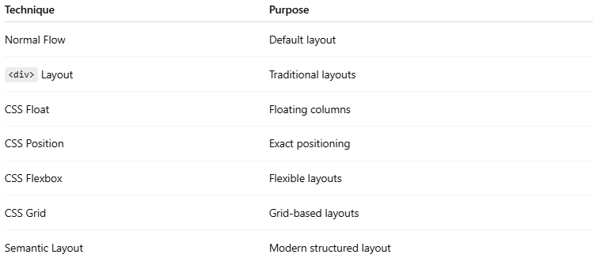
Technique | Purpose
Normal Flow | Default layout
<div> Layout | Traditional layouts
CSS Float | Floating columns
CSS Position | Exact positioning
CSS Flexbox | Flexible layouts
CSS Grid | Grid-based layouts
Semantic Layout | Modern structured layout

1. 📄 Normal Flow Layout
# Source: AI Source: Provided by: [Data Path: Persons Table -> ID Column: 1, Name_En Column: Motasem Essam] -> From: [ChatGPT] on [5/6/2026]
📖 Description
Default HTML layout behavior.
Elements appear:
- top to bottom
- left to right
💻 Example:
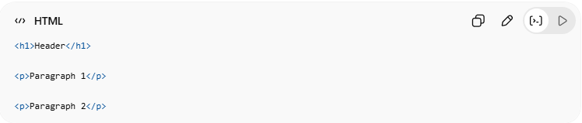
<h1>Header</h1>
<p>Paragraph 1</p>
<p>Paragraph 2</p>

2. 📦 <div> Layout
# Source: AI Source: Provided by: [Data Path: Persons Table -> ID Column: 1, Name_En Column: Motasem Essam] -> From: [ChatGPT] on [5/6/2026]
📖 Description
Uses <div> containers to build page sections.
💻 Example:
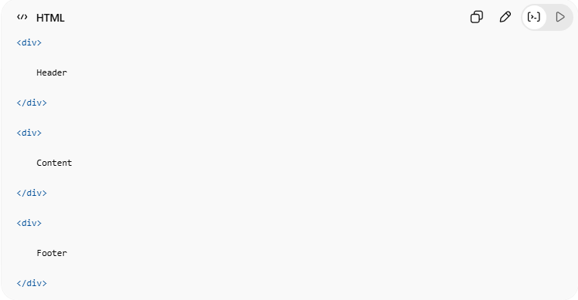
<div>
Header
</div>
<div>
Content
</div>
<div>
Footer
</div>

3. 🌊 CSS Float Layout
# Source: AI Source: Provided by: [Data Path: Persons Table -> ID Column: 1, Name_En Column: Motasem Essam] -> From: [ChatGPT] on [5/6/2026]
📖 Description
Uses float to place columns side by side.
Older technique.
💻 Example:
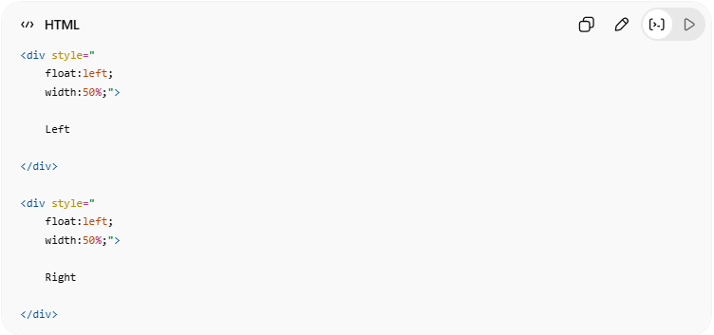
<div style="
float:left;
width:50%;">
Left
</div>
<div style="
float:left;
width:50%;">
Right
</div>

4. 📍 CSS Position Layout
# Source: AI Source: Provided by: [Data Path: Persons Table -> ID Column: 1, Name_En Column: Motasem Essam] -> From: [ChatGPT] on [5/6/2026]
📖 Description
Controls exact element position.
🧩 Common Position Values
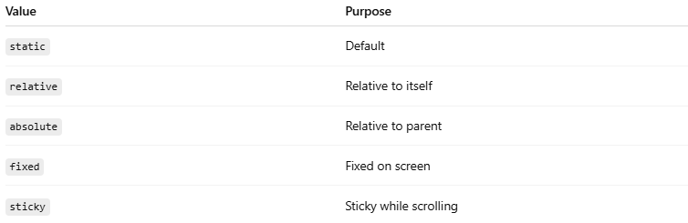
Value | Purpose
static | Default
relative | Relative to itself
absolute | Relative to parent
fixed | Fixed on screen
sticky | Sticky while scrolling
💻 Example:
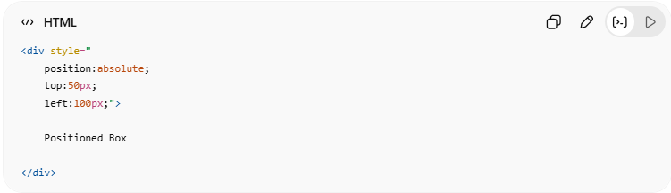
<div style="
position:absolute;
top:50px;
left:100px;">
Positioned Box
</div>

5. 🔄 CSS Flexbox Layout
# Source: AI Source: Provided by: [Data Path: Persons Table -> ID Column: 1, Name_En Column: Motasem Essam] -> From: [ChatGPT] on [5/6/2026]
📖 Description
Modern one-dimensional layout system.
Great for:
- rows
- columns
- alignment
💻 Example:
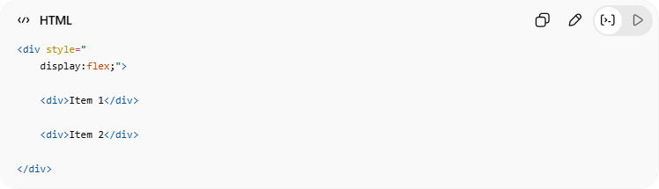
<div style="
display:flex;">
<div>Item 1</div>
<div>Item 2</div>
</div>
🔤 Common Flexbox Properties
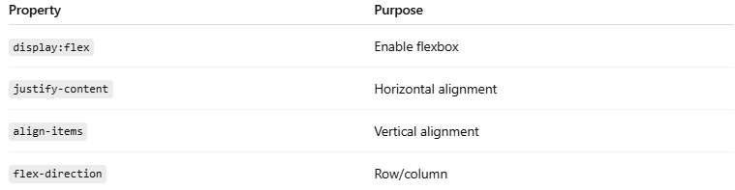
Property | Purpose
display:flex | Enable flexbox
justify-content | Horizontal alignment
align-items | Vertical alignment
flex-direction | Row/column

6. 🧩 CSS Grid Layout
# Source: AI Source: Provided by: [Data Path: Persons Table -> ID Column: 1, Name_En Column: Motasem Essam] -> From: [ChatGPT] on [5/6/2026]
📖 Description
Modern two-dimensional layout system.
Best for:
- full page layouts
- dashboards
- complex grids
💻 Example:
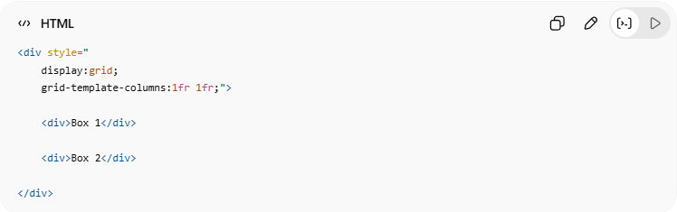
<div style="
display:grid;
grid-template-columns:1fr 1fr;">
<div>Box 1</div>
<div>Box 2</div>
</div>
🔤 Common Grid Properties
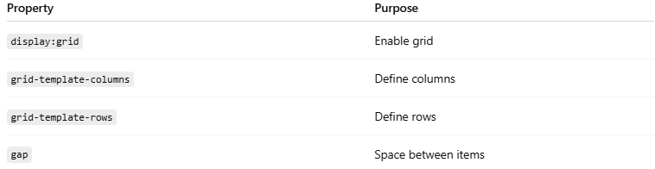
Property | Purpose
display:grid | Enable grid
grid-template-columns | Define columns
grid-template-rows | Define rows
gap | Space between items

7. 🏷️ Semantic Layout
# Source: AI Source: Provided by: [Data Path: Persons Table -> ID Column: 1, Name_En Column: Motasem Essam] -> From: [ChatGPT] on [5/6/2026]
📖 Description
Uses semantic HTML elements for page structure.
🧩 Common Semantic Layout Elements
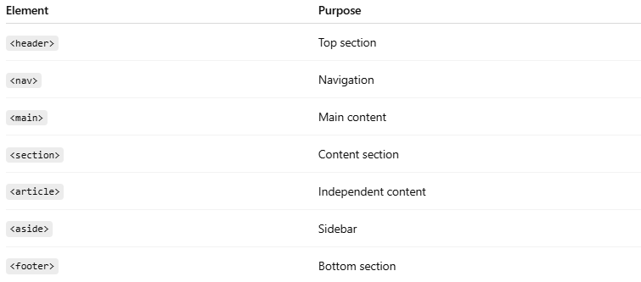
Element | Purpose
<header> | Top section
<nav> | Navigation
<main> | Main content
<section> | Content section
<article> | Independent content
<aside> | Sidebar
<footer> | Bottom section
💻 Example:
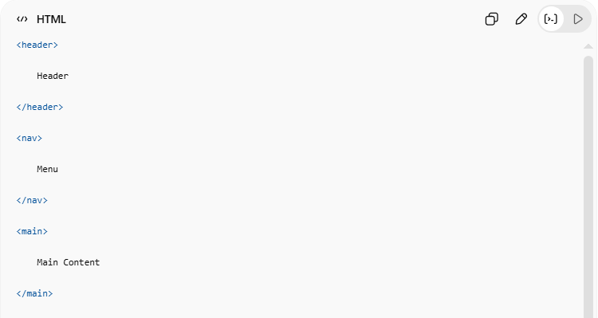
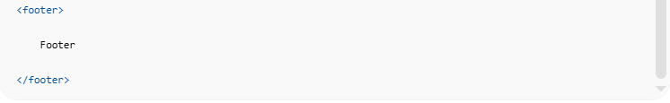
<header>
Header
</header>
<nav>
Menu
</nav>
<main>
Main Content
</main>
<footer>
Footer
</footer>

💻 Example

Full Example
# Source: AI Source: Provided by: [Data Path: Persons Table -> ID Column: 1, Name_En Column: Motasem Essam] -> From: [ChatGPT] on [5/6/2026]
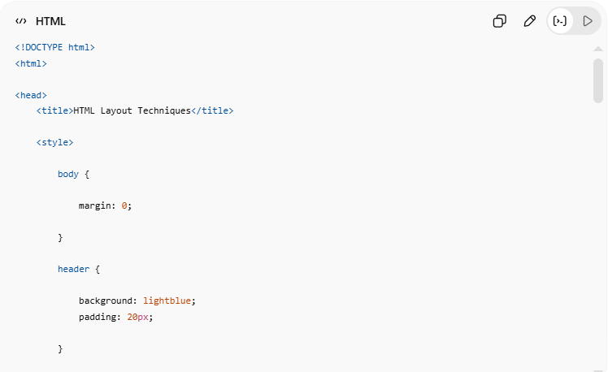
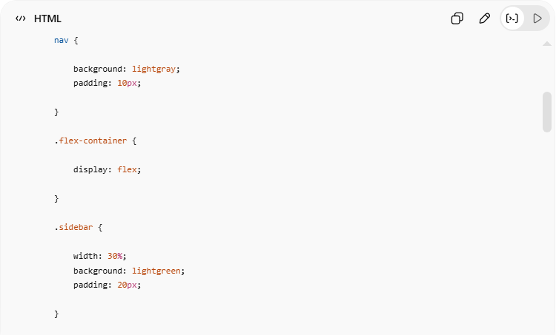
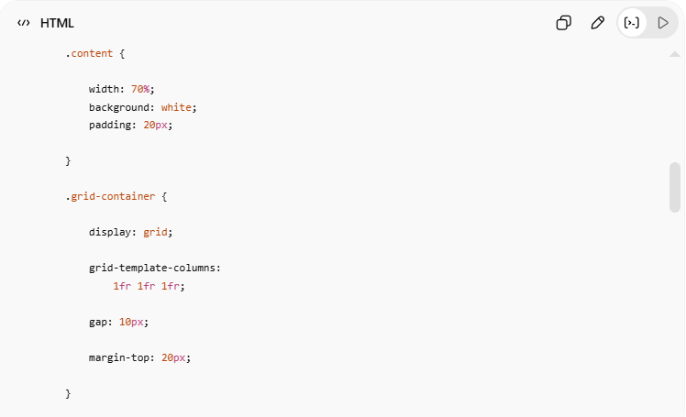
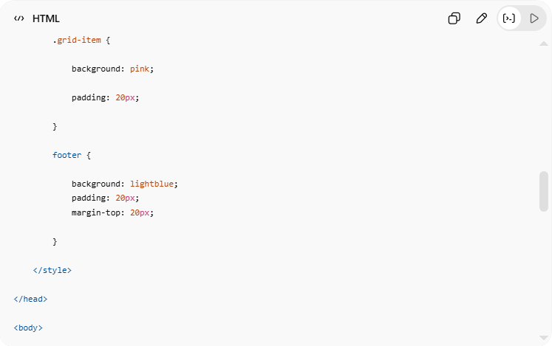
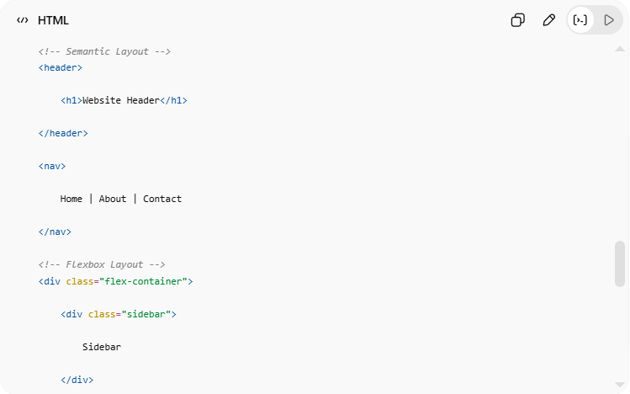
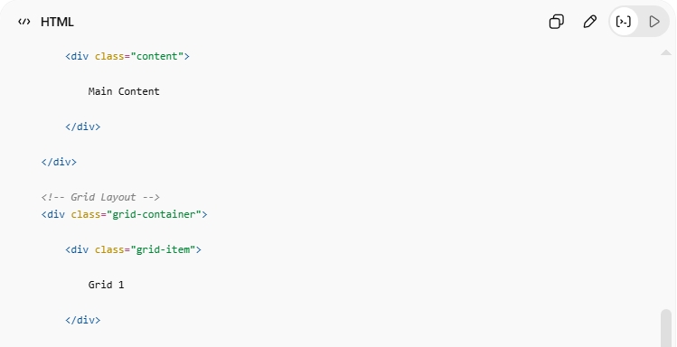
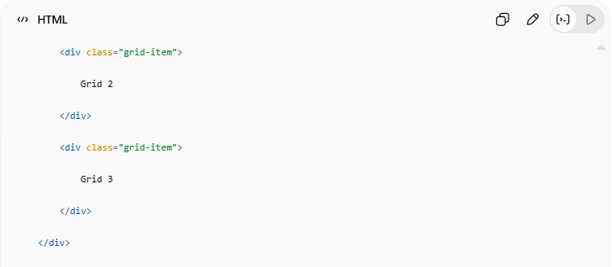
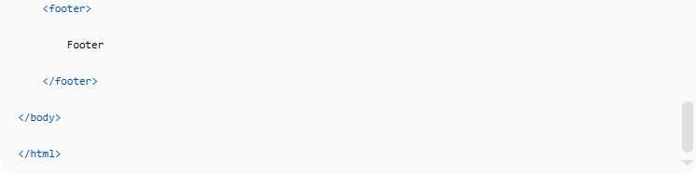
<!DOCTYPE html>
<html>
<head>
<title>HTML Layout Techniques</title>
<style>
body {
margin: 0;
}
header {
background: lightblue;
padding: 20px;
}
nav {
background: lightgray;
padding: 10px;
}
.flex-container {
display: flex;
}
.sidebar {
width: 30%;
background: lightgreen;
padding: 20px;
}
.content {
width: 70%;
background: white;
padding: 20px;
}
.grid-container {
display: grid;
grid-template-columns:
1fr 1fr 1fr;
gap: 10px;
margin-top: 20px;
}
.grid-item {
background: pink;
padding: 20px;
}
footer {
background: lightblue;
padding: 20px;
margin-top: 20px;
}
</style>
</head>
<body>
<!-- Semantic Layout -->
<header>
<h1>Website Header</h1>
</header>
<nav>
Home | About | Contact
</nav>
<!-- Flexbox Layout -->
<div class="flex-container">
<div class="sidebar">
Sidebar
</div>
<div class="content">
Main Content
</div>
</div>
<!-- Grid Layout -->
<div class="grid-container">
<div class="grid-item">
Grid 1
</div>
<div class="grid-item">
Grid 2
</div>
<div class="grid-item">
Grid 3
</div>
</div>
<footer>
Footer
</footer>
</body>
</html>

Real Example
# Source: ScreenShot Source: Provided by: [Persons Table -> ID Column: 1, Name_En Column: Motasem Essam] -> Tool: [Automation Table -> ID Column: 16, Name_En Column: Screen Capture] -> From [Operating System: Windows] on [5/6/2026]
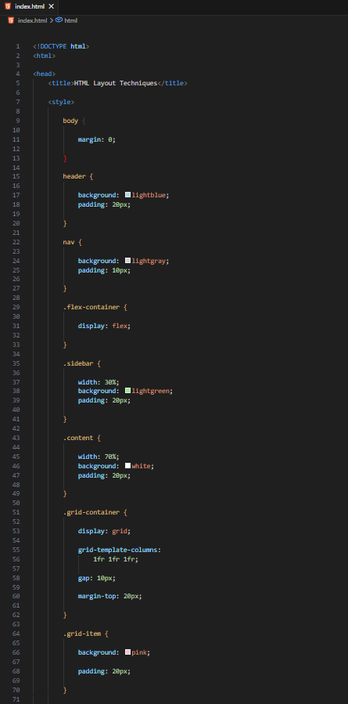
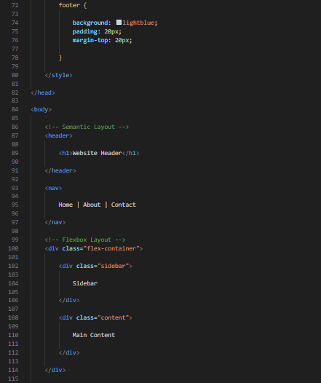
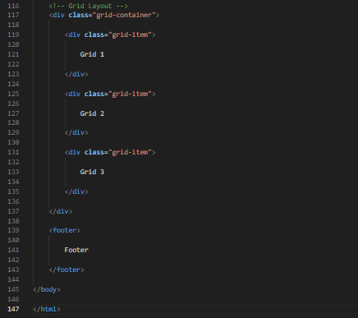
<!DOCTYPE html>
<html>

<head>
<title>HTML Layout Techniques</title>

<style>

body {

margin: 0;

}

header {

background: lightblue;
padding: 20px;

}

nav {

background: lightgray;
padding: 10px;

}

.flex-container {

display: flex;

}

.sidebar {

width: 30%;
background: lightgreen;
padding: 20px;

}

.content {

width: 70%;
background: white;
padding: 20px;

}

.grid-container {

display: grid;

grid-template-columns:
1fr 1fr 1fr;

gap: 10px;

margin-top: 20px;

}

.grid-item {

background: pink;

padding: 20px;

}

footer {

background: lightblue;
padding: 20px;
margin-top: 20px;

}

</style>

</head>

<body>

<!-- Semantic Layout -->
<header>

<h1>Website Header</h1>

</header>

<nav>

Home | About | Contact

</nav>

<!-- Flexbox Layout -->
<div class="flex-container">

<div class="sidebar">

Sidebar

</div>

<div class="content">

Main Content

</div>

</div>

<!-- Grid Layout -->
<div class="grid-container">

<div class="grid-item">

Grid 1

</div>

<div class="grid-item">

Grid 2

</div>

<div class="grid-item">

Grid 3

</div>

</div>

<footer>

Footer

</footer>

</body>

</html>
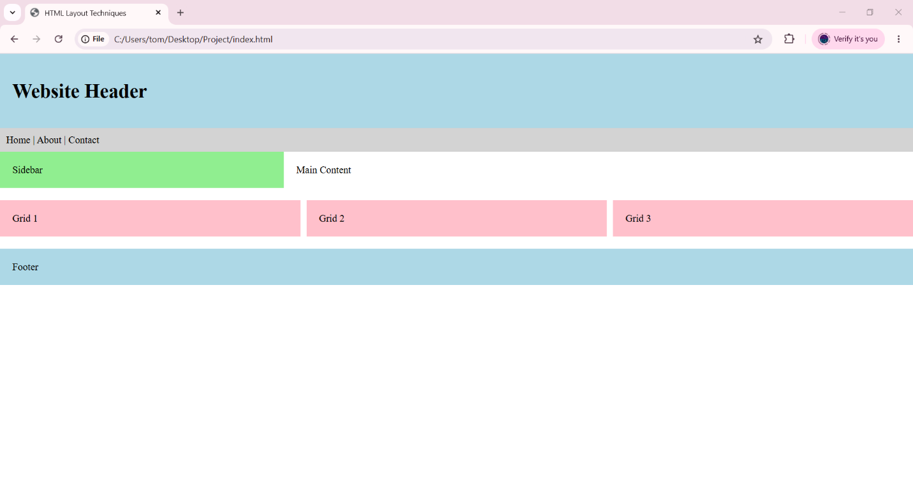

🧪 What You Can Test
# Source: AI Source: Provided by: [Data Path: Persons Table -> ID Column: 1, Name_En Column: Motasem Essam] -> From: [ChatGPT] on [5/6/2026]
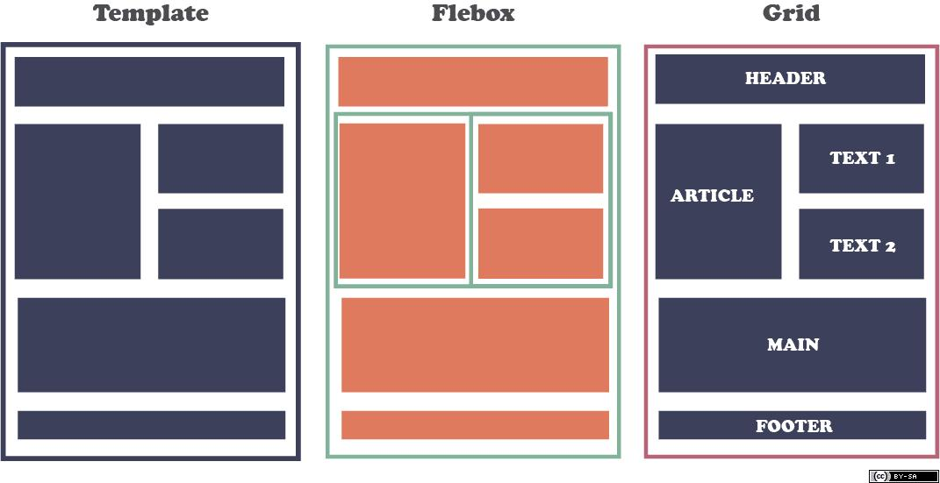
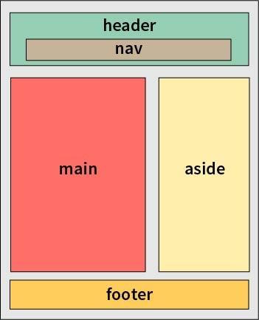
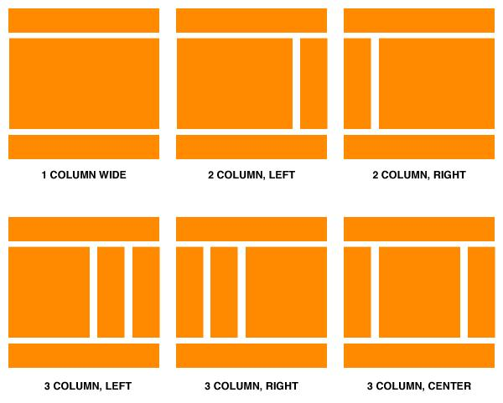
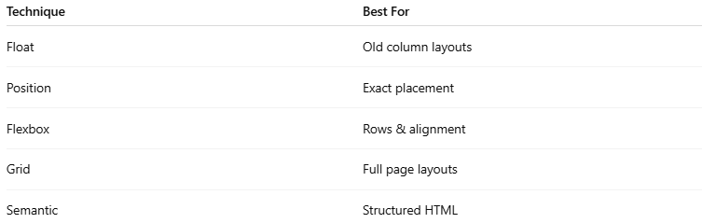
Technique | Best For
Float | Old column layouts
Position | Exact placement
Flexbox | Rows & alignment
Grid | Full page layouts
Semantic | Structured HTML

⚠️ Important Notes

✅ Use Flexbox for simple layouts
# Source: AI Source: Provided by: [Data Path: Persons Table -> ID Column: 1, Name_En Column: Motasem Essam] -> From: [ChatGPT] on [5/6/2026]
👉 Navigation bars, rows

✅ Use Grid for complex layouts
# Source: AI Source: Provided by: [Data Path: Persons Table -> ID Column: 1, Name_En Column: Motasem Essam] -> From: [ChatGPT] on [5/6/2026]
👉 Dashboards and page grids

✅ Prefer semantic HTML
# Source: AI Source: Provided by: [Data Path: Persons Table -> ID Column: 1, Name_En Column: Motasem Essam] -> From: [ChatGPT] on [5/6/2026]
👉 Better accessibility and SEO

❌ Avoid float for modern layouts
# Source: AI Source: Provided by: [Data Path: Persons Table -> ID Column: 1, Name_En Column: Motasem Essam] -> From: [ChatGPT] on [5/6/2026]
👉 Mostly outdated

🚀 In short:
# Source: AI Source: Provided by: [Data Path: Persons Table -> ID Column: 1, Name_En Column: Motasem Essam] -> From: [ChatGPT] on [5/6/2026]
Modern HTML layouts are commonly built using Flexbox, Grid, and semantic elements, while older techniques include floats and positioning.

